Server Disconnect

This use case is related to the client,edge server and central index server.When the player choose to exit the game or the central server choose to change a server, the edge server send a request to the central index server and then the edge server disconnect with the client and release the resource when it receive the confirm command from the central index.As the same time,the central server store the record the information that this edge server is free now when it send the command to disconnect the edge server.

We choose to use mediator pattern to design this use case because the mediator pattern can change one-to-many associations between objects into one-to-one associations to increase the flexibility of the system and make the system be easy to maintain and expand.What is more,it can also make the coupling between the original objects loose, and change the interaction between them independently.As the central server control all the edge server at the same time,this kind of design can make the process be as possibly easy as that there is just one link between the edge and central server.

**Mediator Pattern**

The structure is shown following.

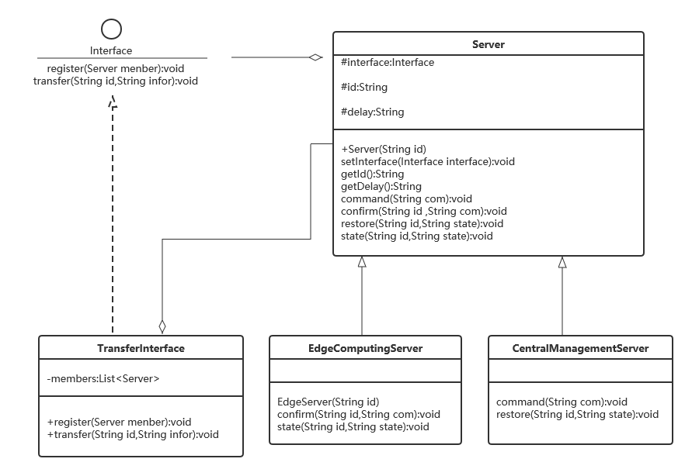

The code is shown following.

